

Short Exam 1 – Computer Vision 2026

1 hour – No document allowed – The exam will be graded on 17 points.

Part 1: Geometric 2D transformations

Question 1 (2 points - 5 mn): Match the linear transformation matrices listed in the first column to their interpretations in the second column.
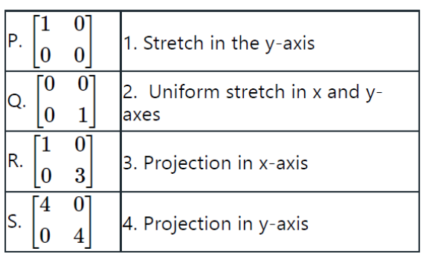
Select one answer among the following
1. P-1, Q-2, R-3, S-4
2. P-2, Q-3, R-4, S-1
3. P-3, Q-4, R-1, S-2
4. P-4, Q-1, R-2, S-3

Question 2 (4 points - 20 mn): Which transformation was applied to the left image in order to get the right image ?
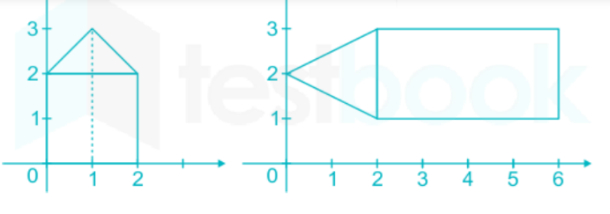
Select one answer among the following
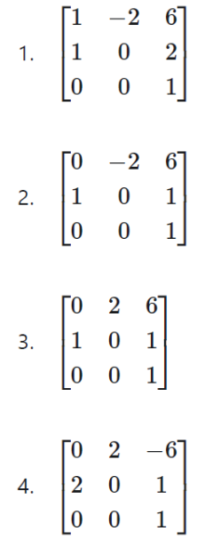

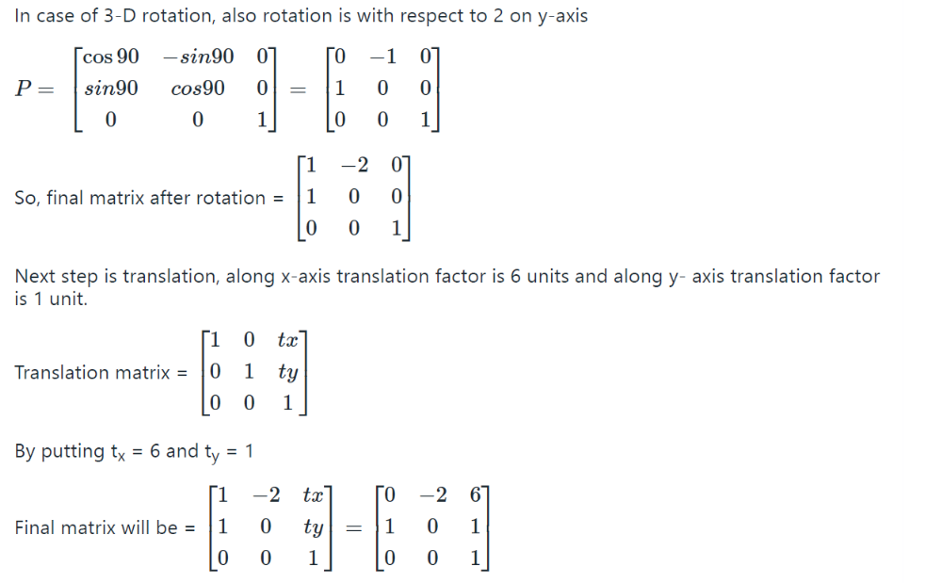

Question 3 (6 points - 15 mn): Figure (a) shows a “barn” in its original orientation. Let us consider that: for a z-roll, the x-axis rotates to the y-axis ; for an x-roll, the y-axis rotates to the z-axis ; for a y-roll, the z-axis rotates to the x-axis. Which figure among Figures (b), (c) and (d) corresponds to a -70° x-roll ? a 30° y-roll ? and a -90° z-roll ? Write the rotation matrix associated to each of these rotations.

y
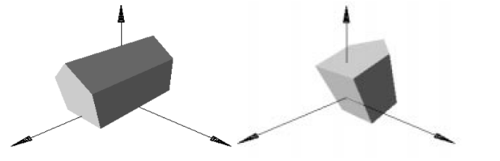
z x
(a) (b)

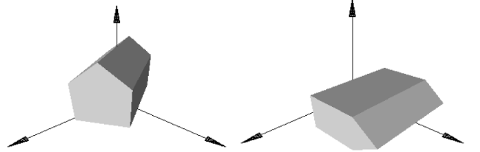
(c) (d)

Ans:
Figure (b) corresponds to a -70° x-roll
Figure (c) corresponds to a 30° y-roll
Figure (d) corresponds to a -90° z-roll

Ans:
From (a) to (b) with a -70° x-roll =

1 0 0 0

0 Cos(-70) -Sin(-70) 0

0 Sin(-70) Cos(-70) 0

0 0 0 1

From (a) to (c) with a 30° y-roll =

Cos(30) 0 Sin(30) 0

0 1 0 0

-Sin(30) 0 Cos(30) 0

0 0 0 1

From (a) to (d) with a -90° z-roll =

Cos(-90) -Sin(-90) 0 0

Sin(-90) Cos(-90) 0 0

0 0 1 0

0 0 0 1

Question 4 (5 points - 15 mn):
- Which transformation(s) preserve lines, parallelism, angles and length? Answer : Translation ? Rigid body ? Similarity ? Affine ? Projective ?
- Which transformation(s) preserves lines, parallelism, angles but not length? Answer : Translation ? Rigid body ? Similarity ? Affine ? Projective ?
- Which transformation(s) preserves lines, parallelism, but not angles and length? Answer : Translation ? Rigid body ? Similarity ? Affine ? Projective ?
- Which transformation(s) preserves lines, but not parallelism, angles and length? Answer : Translation ? Rigid body ? Similarity ? Affine ? Projective ?
- Figure (b) corresponds to a Rigid body transformation. Figure (c) corresponds to an Affine transformation. Figure (d) corresponds to a Projective transformation.


(a) Original (b) (c) (d)

